The Islamia University of Bahawalpur
Faculty of computing department of Information technology


Final year project
Project Title: Data-driven insights of Learning Management system of Activity logs.

Submitted By. Ayesha Shafiq
Roll No. F22BINFT1M01096
Department: Information technology
Submitted To.
Sir Mustafa Hameed

Meeting Detail
Sr No | Details | Date | Supervisor signature

Summary:
Learning Management Systems (LMS) are widely used in universities to manage online learning, upload lectures, share assignments, and conduct quizzes. Every action a student or teacher performs inside the LMS such as logging in, opening a lecture, attempting a quiz, posting in forums, or downloading files creates an activity log. These logs contain valuable information about how students learn, how active they are, and whether they might be struggling in a course. However, most universities do not use these logs effectively. Teachers usually cannot manually check thousands of activities for hundreds of students, and the LMS only shows simple statistics, not deep insights. This makes it difficult for instructors to identify which students are at risk of low performance before exams. This project aims to solve this problem by building a system that uses machine learning to study LMS activity logs and convert them into useful insights. The system will analyze student behavior patterns, predict academic performance, and highlight students who need help. It will also show charts and dashboards so teachers and admins can easily understand the data. The project will allow admins to import LMS logs, clean and process the data, run predictive models, and display the results in a simple visual form. Teachers will be able to see which students are doing well, who is inactive, and who might fail if no support is given. The system will help universities make better decisions, improve learning outcomes, and support students who may be struggling. This SRS explains all the system requirements in detail, including functional requirements, non-functional requirements, use cases, diagrams, and supported technologies. The document provides a clear understanding of what the system will do, who will use it, and how it will work.

Table of Contents
Introduction 5
1.1 Purpose 5
1.2 Scope 5
1.3 Out-of-Scope 6
1.4Product Perspective 6
1.5User Characteristics 6
1.6 Similar Apps / Literature Review 6
1.7 Proposed Technologies 6
Functional Requirements 7
FR001 User Login 7
FR002 User Registration 7
FR003 Import LMS Logs 7
FR004 Data Cleaning 8
FR005 Data Analysis 8
FR006 Machine Learning Prediction 8
FR007 At-Risk Student Alerts 8
FR008 Instructor Dashboard 8
FR009 Admin Dashboard 9
FR010 Student Profile View 9
FR011 Report Export 9
FR012 Log Search 9
FR013 API Integration 9
FR014 User Role Management 10
FR015 Mobile App Access 10
Non-Functional Requirements 10
4.1 Performance Requirements 10
4.2 Security Requirements 10
4.3 Reliability Requirements 10
4.4 Usability Requirements 10
4.5 Scalability requirement 10
Use case and Flow of process 10
Reference 11

Introduction
Universities rely on Learning Management Systems (LMS) to support digital and blended learning. At The Islamia University of Bahawalpur, thousands of students and teachers interact with the LMS every day. Students log in to access lectures, submit assignments, attempt quizzes, and participate in discussions. Teachers use the LMS to upload content, post announcements, check student submissions, and record grades. All these activities create large amounts of data, known as activity logs. Although the LMS stores this data, it mostly remains unused because teachers do not have the time or tools to analyze it. The LMS usually shows only basic information such as total logins or quiz scores. It does not provide smart insights or early warnings about students who may be at risk of performing poorly. As a result, teachers often find out about struggling students too late usually after exams. This project aims to introduce an intelligent system that analyzes LMS activity logs to provide meaningful insights. The idea is to use machine learning to understand patterns in student behavior. For example, students who rarely log in, spend little time on course materials, or skip quizzes may be at higher risk of failure. The system will process the logs, study these patterns, and give predictions such as:
- Students are active
- Students are inactive
- Students may fail
- How learning behavior affects performance
The system also provides user-friendly dashboards for instructors and administrators, showing charts, graphs, and clear summaries of student performance and engagement. This helps teachers take early action, guide students, or arrange extra support for those who need it. The system will not replace the existing LMS. Instead, it will work alongside it as an additional tool for analytics. Logs can be imported from Moodle, Canvas, or any other LMS used by the university. This approach makes the project flexible and easy to integrate. Overall, the system will help the university move toward data-driven decision-making. It will improve academic monitoring, help identify struggling students early, and support teachers in managing large classes more effectively.
Purpose
The purpose of this SRS is to formally define all requirements, constraints, and specifications for the Data-Driven Insight from LMS Activity Logs system. It aims to:
- Provide behavioral analytics based on LMS activity logs.
- Predict academic performance using machine learning.
- Identify at-risk students early for timely intervention.
- Show results through dashboard
- Help teacher and admin make better decision
Scope
Importing LMS logs
Cleaning and processing log data
Running machine learning models
Generating dashboards
Showing alerts for at-risk students
Secure login system
Out-of-Scope
Modification of core LMS functionalities (course creation, grading, etc.).
Student-facing mobile learning content.
Managing university server
Direct LMS teaching tools.
Product Perspective
The analytics system functions as an independent analytical module that connects to the LMS via APIs or file export interfaces. It processes large volumes of log data, stores analytics results in a database, and offers dashboards accessible through a web or mobile interface. It does not replace existing LMS functionality but adds intelligent insight capabilities.
User Characteristics
Admin: Highly technical staff responsible for managing system configuration, user roles, and data pipelines.
Instructor / Faculty: Moderately technical users who interpret dashboards, monitor class engagement, and take interventions.
Academic Advisors: Non-technical users requiring simplified visual insights.
Data Analyst: Skillful users interpreting advanced ML outputs.
Student (Limited Role): May receive automated feedback or notifications.
Similar Apps / Literature Review
Moodle Analytics
Features: Basic engagement reports, completion tracking.
Shortcomings: Limited predictive capabilities; manual data export required.
Canvas Data Portal
Features: downloadable datasets.
Shortcomings: requires external processing.
Blackboard Analytics
Features: Dashboard analytics, student performance trends.
Shortcomings: High licensing cost, less customizable predictive logic.
This project improves on them by offering customizable machine-learning-based predictions, localized to institutional needs.
Proposed Technologies:
Programming Language: Python / R
Database: MySQL
Visualization: Power BI
Machine Learning Libraries: scikit-learn, pandas,
Platform: Moodle, Google Classroom, or dummy LMS dataset
Requirement:
The system is designed to take LMS activity logs, process them, and convert them into useful insights for teachers and administrators. The functions mainly include log importing, data processing, predictions, dashboards, alerts, and secure user management.
Functional requirement:
FR001 User Login
Name: FR001
Purpose: To allow users to securely log in to the system.
User(s): Admin, Teacher, Advisor
Input: Email, Password (minimum 8 characters, includes a number)
Output: User is logged into the dashboard.
FR002 User Registration
Name: FR002
Purpose: To allow admins to create new user accounts.
User(s): Admin
Input: Name, Email, Password, Role
Output: New user added to the system.
FR003 Import LMS Logs
Name: FR003
Purpose: To upload LMS logs from a file or API.
User(s): Admin
Input: CSV file or LMS API credentials
Output: Logs stored in the system database.
FR004 Data Cleaning
Name: FR004
Purpose: To clean and prepare the raw logs for processing.
User(s): System (automatic)
Input: Raw log records
Output: Clean and structured data.
FR005 Data Analysis
Name: FR005
Purpose: To calculate basic statistics like number of logins, time spent, and quiz attempts.
User(s): System
Input: Cleaned data
Output: Summary statistics stored in the database.
FR006 Machine Learning Prediction
Name: FR006
Purpose: To predict student performance using machine learning models.
User(s): System
Input: Processed student activity data
Output: Prediction score (e.g., Low Risk, Medium Risk, High Risk)
FR007 At-Risk Student Alerts
Name: FR007
Purpose: To notify teachers when a student’s risk status is high.
User(s): Teacher, Advisor
Input: Prediction results
Output: Alerts shown on dashboard or sent via email/mobile.
FR008 Instructor Dashboard
Name: FR008
Purpose: To show teachers clear visual analytics.
User(s): Teacher
Input: Analysis and prediction data
Output: Charts, graphs, engagement summaries.
FR009 Admin Dashboard
Name: FR009
Purpose: To let admins manage overall system operations.
User(s): Admin
Input: System summary data
Output: System usage statistics, data import reports.
FR010 Student Profile View
Name: FR010
Purpose: To display a student’s activity summary and prediction.
User(s): Teacher, Advisor
Input: Student ID
Output: Student activity timeline, performance prediction.
FR011 Report Export
Name: FR011
Purpose: To allow users to download student or course reports.
User(s): Teacher, Admin
Input: Report type (PDF/Excel)
Output: Downloaded report file.
FR012 Log Search
Name: FR012
Purpose: To let users search logs for specific students or dates.
User(s): Admin
Input: Keywords, dates, student ID
Output: Filtered log results.
FR013 API Integration
Name: FR013
Purpose: To connect with LMS platforms through API.
User(s): System
Input: API key or authentication token
Output: Automatic fetching of logs.
FR014 User Role Management
Name: FR014
Purpose: To assign or change user roles.
User(s): Admin
Input: User ID, new role
Output: Updated role permissions.
FR015 Mobile App Access
Name: FR015
Purpose: To give mobile app access to the dashboard.
User(s): All roles
Input: User login credentials
Output: Dashboard loaded on mobile.
Non-Functionality Requirement:
The system should work fast by loading dashboards in under three seconds and completing machine-learning predictions within ten seconds. It must also be capable of processing large activity log files of up to one million records. For security, all passwords must be saved in encrypted form, and only authorized users should be able to view prediction results. Administrative features must be protected using role-based access control. To ensure reliability, the system should have less than one percent downtime each month, create daily data backups, and make sure no logs are lost during processing. The system should also be easy to use, with a clean and simple dashboard design that users can learn within one hour. Icons and labels must be clear and easy to understand. In terms of scalability, the system should be able to handle increasing amounts of logs, support adding new machine-learning models in the future, and work for multiple departments and courses. For maintainability, the code should be well-documented, updates should not require system downtime, and any errors should be simple to locate and fix.
Use Case and Flow of Process:
Data-Driven Insights from LMS Activity Logs use case involves an Administrator who logs into the LMS and selects the "View Activity Logs" option. The system retrieves and preprocesses the activity logs, which include data like logins, quiz attempts, and forum posts. It then analyzes the data to identify trends and generates insights, which are presented to the Admin in a visual format (graphs or tables). The Admin can view and save these insights. Alternative flows include scenarios where data is missing, the system cannot connect to the LMS, or there is insufficient data for analysis. In such cases, the Admin can either proceed with available data, retry the connection, or adjust the analysis parameters. If needed the process can be canceled at any point.

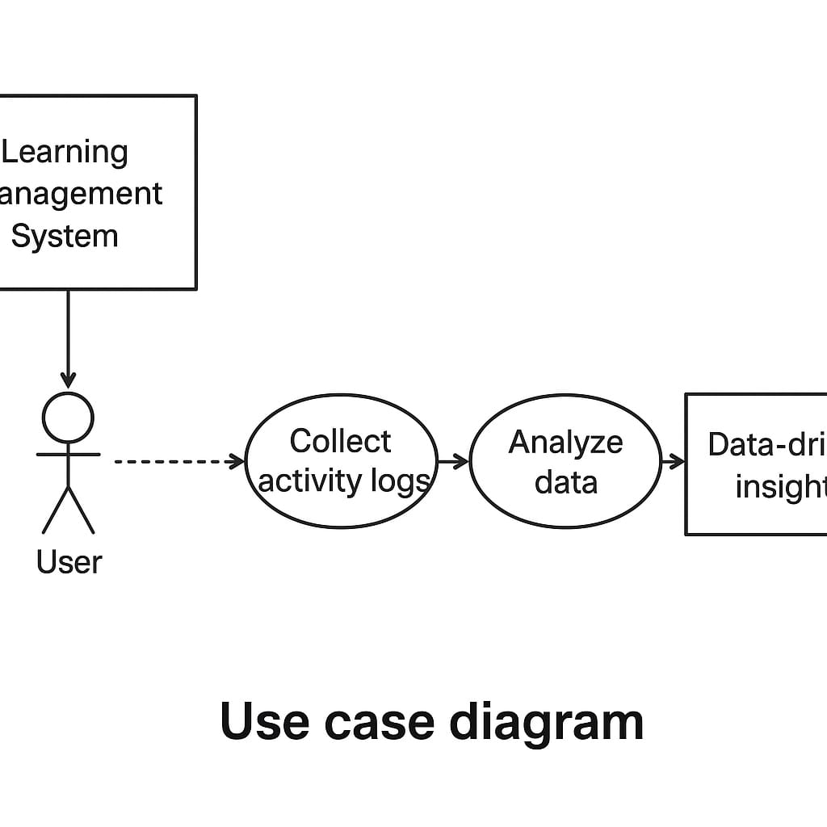
LMS activity logs record detailed interactions such as logins, page views, downloads, and submissions.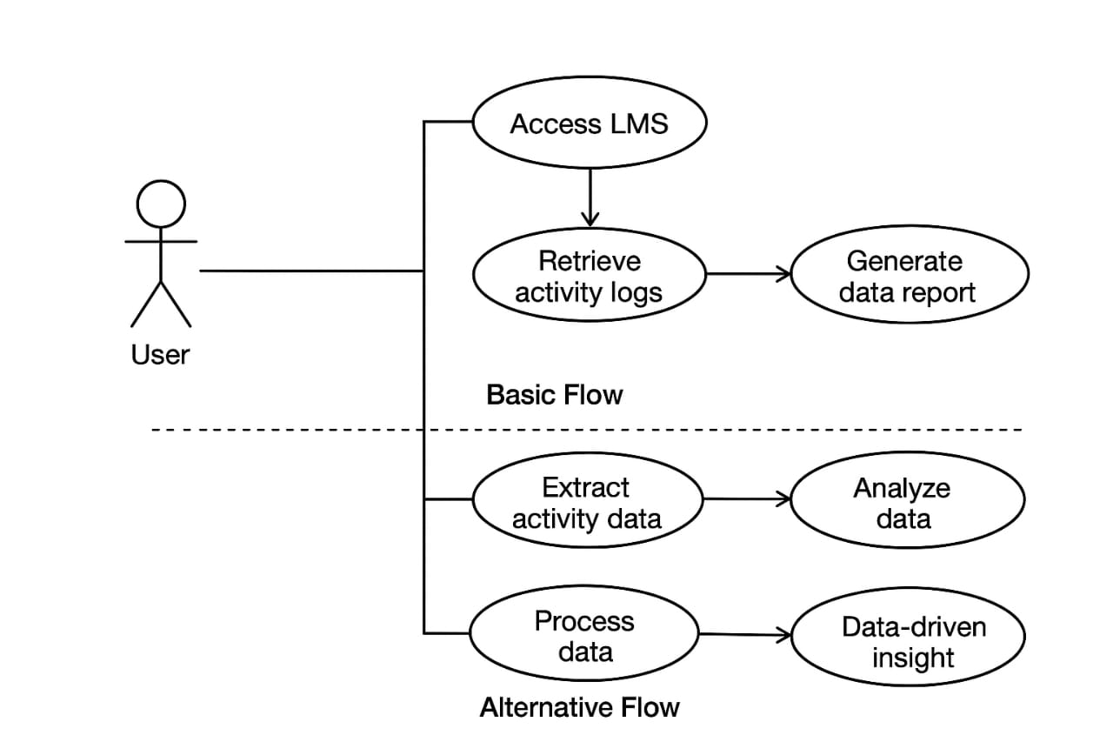

REFERENCES
- J. Brown and M. Davis, “Analyzing Learning Management System Activity Logs for Student Performance Prediction,” IEEE Transactions on Learning Technologies, vol. 15, no. 3, pp. 410–422, 2022.
- Khan, S. Raza, and L. Ahmed, “Data-Driven Approaches for Academic Analytics: A Comprehensive Survey,” International Journal of Educational Technology, vol. 9, no. 2, pp. 55–68, 2021.
- R. Patel and K. Thompson, “Improving Course Design through LMS Usage Insights,” in Proc. 2020 IEEE Int. Conf. Educational Data Mining (EDM), pp. 112–119, 2020.
- M. Zhang, Y. Li, and H. Choi, “Visualization Techniques for Large-Scale Learning Activity Data,” Journal of Information Systems Research, vol. 18, no. 1, pp. 77–93, 2023.
- S. Williams, “A Framework for Predictive Analytics in University LMS Platforms,” IEEE Access, vol. 10, pp. 21745–21758, 2022.

